Ideation Phase
Define the Problem Statements
Date | 20 February 2026
Team ID | LTVIP2026TMIDS81521
Project Name | DocSpot: Seamless Appointment Booking for Health
Maximum Marks | 2 Marks

Customer Problem Statement
- Who is experiencing the problem? Freelancers—both newcomers and experienced professionals—across various domains such as design, writing, tech, and marketing.
- What are they trying to accomplish? They aim to find legitimate, relevant, and well-paying freelance jobs quickly and efficiently, without spending excessive time sorting through spam or low-quality listings.
- What is standing in their way?
- Overcrowded platforms with inconsistent filtering and irrelevant job results
- Scam listings or jobs with unclear expectations and poor compensation
- Delayed response times and lack of client transparency
- Difficulties in establishing trust and showcasing portfolios effectively
- Competitive saturation leading to underbidding wars
- How are they currently addressing this issue?
- Subscribing to multiple freelance platforms and manually sifting through listings
- Using job aggregators, which often lead to outdated or duplicate listings
- Joining social media or niche communities that may lack structure or security

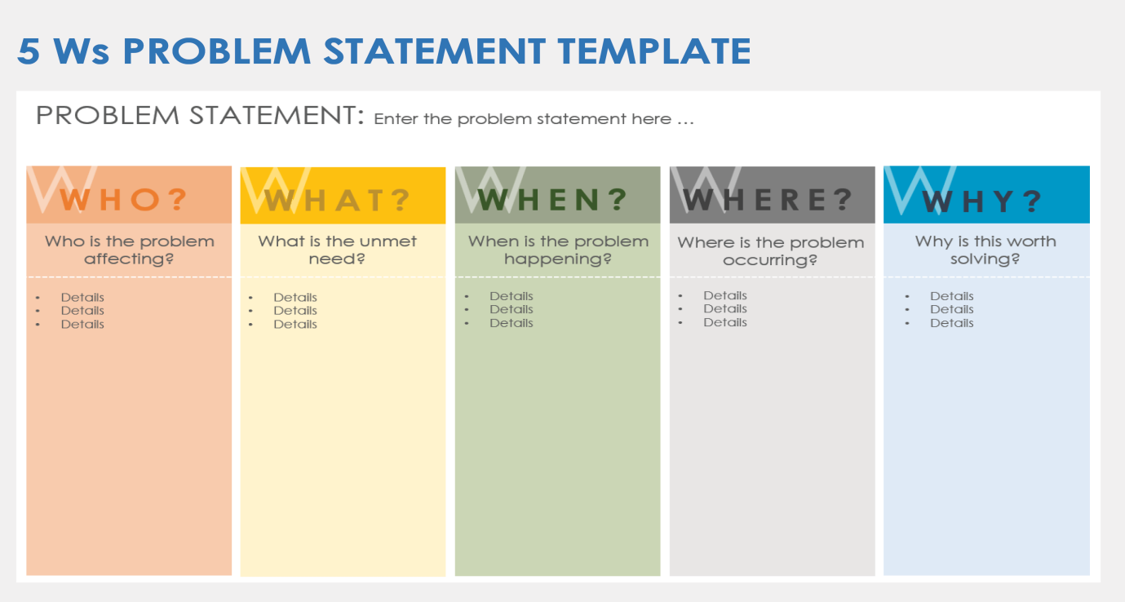

Problem Statement (PS) | I am (Customer) | I’m trying to | But | Because | Which makes me feel
PS-1 | a working professional with a tight schedule | book a doctor’s appointment quickly without phone calls or long wait times. | most clinics don’t have real-time booking systems or clear availability info | their systems are outdated or fragmented | frustrated and anxious about my health getting worse while waiting.
PS-2 | a general physician running a small clinic. | manage patient bookings efficiently and reduce no-shows. | my current tools are manual or not tailored to healthcare workflows. | I cannot afford or understand complex clinic manageme-nt systems. | stressed and underpaid despite my busy schedule.

